Ex 1K – Applications of Linear Equations
Learning Intentions:
- To be able to create equations from worded, practical scenarios
- To be able to apply the methods of solving simultaneous equations to real world contexts

In this lesson, we are going to apply our knowledge of solving simultaneous equations to worded problems. This always adds an element of difficulty as adding context makes things more complicated and generating equations can be challenging. I recommend following these steps:
- Define the variables clearly
- Use the info to produce two linear equations
- Solve them simultaneously using the most appropriate method
- Write your solution back in the context of the question

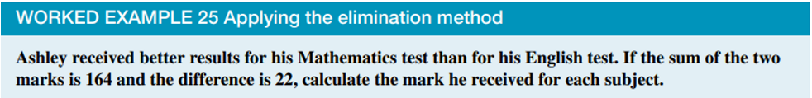

____________________________________________________________________________________________________________________________________________________________________________________________________________________________________________________________________________________________________________________________________________________________________


____________________________________________________________________________________________________________________________________________________________________________________________________________________________________________________________________________________________________________________________________________________________________


____________________________________________________________________________________________________________________________________________________________________________________________________________________________________________________________________________________________________________________________________________________________________
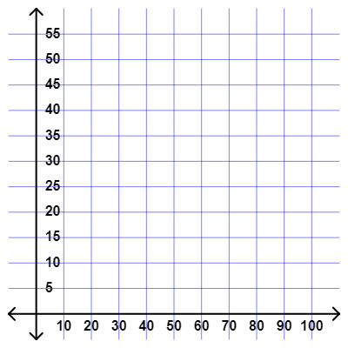

Now try:

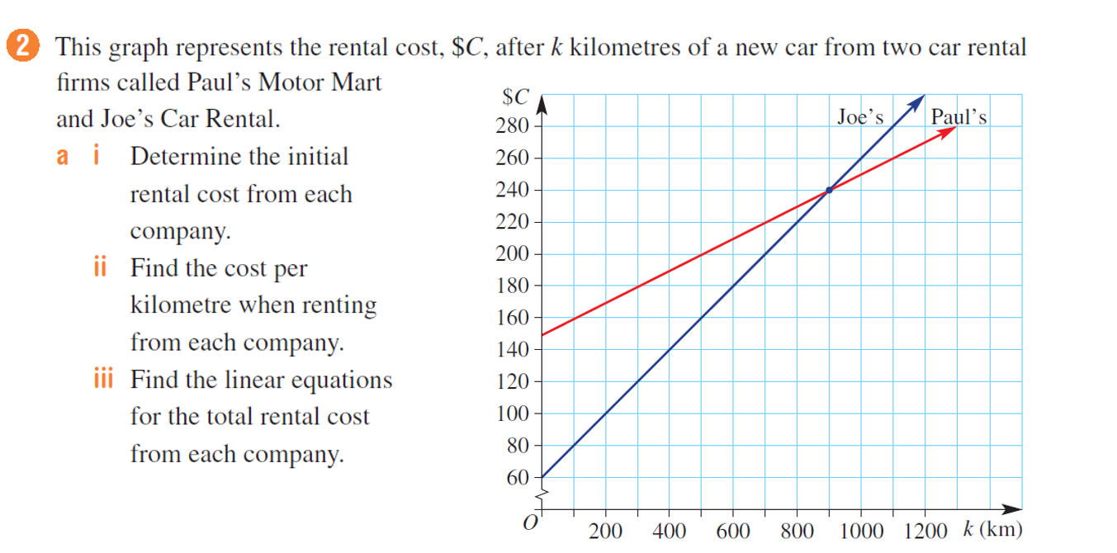
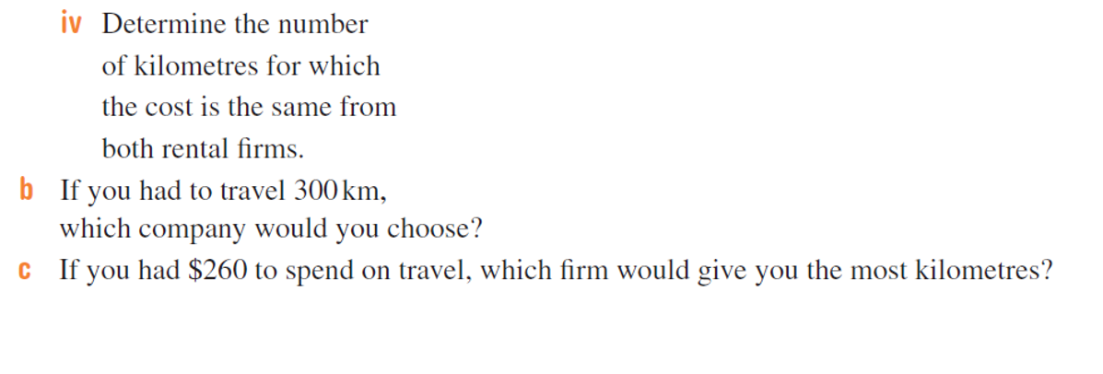

So far, we have only solved simultaneous equations algebraically.
Today we look at what is perhaps an even simpler method: accurately sketching each graph and identifying the point where they cross over each other.

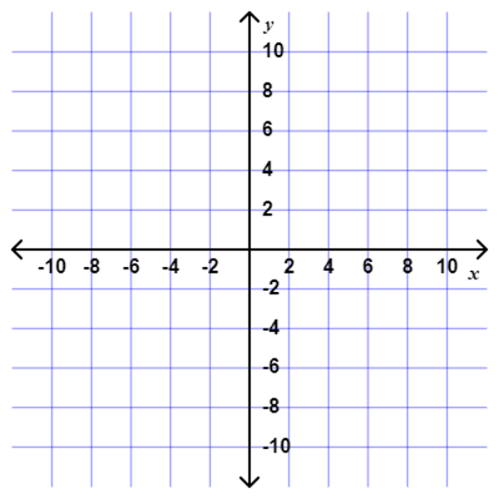


_______________________________________________________________________________________________________________________________________________________________________________________________________________________________________________________________________________________________________________________________________________________________________________________________________________________________________________________________________________________________________________________________________________________________________________________________________________________________________________

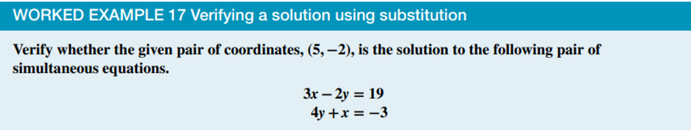
___________________________________________________________________________________________________________________________________________________________________________________________________________________________________________________________________________

Parallel Lines
Parallel lines are straight lines that run next to each other forever, never meeting.
In the context of linear equations, parallel lines have the same gradient. To check if two linear equations are parallel, they both need to be in the form $y=mx+c$ (you may need to rearrange one or both equations).
If $m_{1}≠m_{2}$ | There is one solution
If $m_{1}=m_{2}$ and $c_{1}≠c_{2}$ | There are no solutions (the lines are parallel)
If $m_{1}=m_{2}$ and $c_{1}=c_{2}$ | There are infinite solutions (they are the same line)

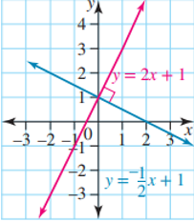
Perpendicular Lines
Perpendicular lines meet at a right angle.
Two linear graphs are perpendicular if the product of their gradients is equal to -1.
Two linear equations, $y=m_{1}x+c_{1}$ and $y=m_{2}x+c_{2}$, are perpendicular if $m_{1}×m_{2}=-1$




